
A PROJECT REPORT ON
UNIVERSITY ACADEMIC MANAGEMENT
DATABASE SYSTEM
Submitted in partial fulfilment of the requirements of the
DBMS Capstone Project (Review – I & Review – II), Batch Number: 8
Submitted by
25B11AI494 – K. Hemanth Sai Venkata Vidya Sagar
25B11AI281 – M. Ravi Teja
25B11AI084 – B. Ganesh
26B21AI080 – N. Subbarao

Under the Guidance of
Dr. P. Kishorekumar
Associate Professor, Department of Artificial Intelligence & Machine Learning
DEPARTMENT OF ARTIFICIAL INTELLIGENCE & MACHINE LEARNING
ADITYA UNIVERSITY
Academic Year: 2026 – 27

SCHOOL OF COMPUTING

Department of Artificial Intelligence and Machine Learning

CERTIFICATE

This is to certify that the Cornerstone project work entitled "UNIVERSITY ACADEMIC MANAGEMENT DATABASE SYSTEM" is submitted by

K. Hemanth Sai Venkata Vidya Sagar-AIML (25B11AI494)

M. Ravi Teja-AIML (25B11AI281)

B. Ganesh-AIML (25B11AI084)

N. Subbarao-AIML (26B21AI080)

In partial fulfillment of the requirements for the award of the B.Tech. degree in Artificial Intelligence and Machine Learning for the academic year 2026-2027.

Project Guide Head of the Department:

Dr. P. Kishorekumar, PhD. Dr. Kovvuri N Bhargavi

Associate Professor, Department of AIML AssociateProfessor&HOD

DECLARATION

We hereby declare that the Cornerstone project entitled " UNIVERSITY ACADEMIC MANAGEMENT DATABASE SYSTEM " is original and is submitted to ADITYA UNIVERSITY, Surampalem, in partial fulfillment of the requirements for the award of the B.Tech. Degree in Artificial Intelligence and Machine Learning. We further declare that this project work has not been submitted, either in full or in part, for the award of any degree in this or any other institution. We also confirm that this work complies with the Institutional Academic Integrity and AI Usage Policy.

Place: Surampalem

Date:

By

K. Hemanth Sai Venkata Vidya Sagar-AIML (25B11AI494)

M. Ravi Teja-AIML (25B11AI281)

B. Ganesh-AIML (25B11AI084)

N. Subbarao-AIML (26B21AI080)

ACKNOWLEDGEMENT
It is with immense pleasure that we express our sincere gratitude to our Cornerstone Project Guide, Dr. P. Kishorekumar, PhD. Associate Professor, Department of AIML, who has guided us throughout the project. His valuable support, encouragement, and guidance have greatly contributed to the successful completion of this work.
We would like to thank our Deputy Heads of the Department, Dr. B. Manikyala Rao, Associate Professor, Dr. R. Suneetha, Assistant Professor and Dr. D. Veeraswamy, Assistant Professor for their support and valuable suggestions.
Our deepest thanks to our Head of the Department Dr. K. Naga Bhargavi, Associate Professor & HOD, for her inspiration and for providing all the necessary facilities and resources required for this project.
We also extend our sincere thanks to Dr. M.V. Rajesh, Associate Dean, School of Computing for their encouragement and support during the course of our project.
We would like to express our sincere gratitude to Dr. G. Suresh, Registrar, Dr. A. Ramesh, Pro Vice-Chancellor (Engineering & Sciences), Dr. S. Rama Sree, Pro Vice-Chancellor (Academics), Dr. M.B. Srinivas, Vice-Chancellor, Dr. M. Sreenivasa Reddy, Deputy Pro Chancellor and Management, Aditya University for providing excellent infrastructure and state-of-the-art laboratories.
Finally, we would like to thank the faculty members, lab technicians, non-teaching staff, and our friends who have directly or indirectly supported us in completing this Cornerstone project successfully.
BY
K. Hemanth Sai Venkata Vidya Sagar (25B11AI494)
M. Ravi Teja (25B11AI281)
B. Ganesh (25B11AI084)
N. Subbarao (26B21AI080)

TABLE OF CONTENTS
CERTIFICATE 2
ACKNOWLEDGEMENT 3
ABSTRACT 5
LIST OF FIGURES 5
LIST OF TABLES 5
ACRONYMS 5
1. Introduction 7
2. System Analysis 8
3. Database Design 9
4. ER Diagram 11
5. Relational Schema 11
6. Table Design 12
7. Normalization 15
8. SQL Implementation 16
9. SQL Queries & Screenshots 17
10. Conclusion 22
11. Future Enhancements 22
12. References 22

ABSTRACT
The University Academic Management Database System is a centralized relational database designed to organize and manage the core academic information of a university. The system stores and manages information related to departments, students, faculty, courses, enrollments, examinations, and results across seven related tables. The database minimizes redundancy, maintains data integrity through primary keys, foreign keys, NOT NULL, UNIQUE, and CHECK constraints, and supports efficient retrieval of academic information using SQL. The design is normalized up to Third Normal Form (3NF), reducing update anomalies and improving consistency. The project was carried out in two stages: Review – I covered requirement analysis and conceptual/logical design (ER diagram and relational schema), and Review – II covered implementation of the schema in MySQL along with DDL, DML, DQL, joins, aggregate queries, CRUD operations, views, and data-integrity demonstrations. The system provides a structured foundation for student management, faculty management, course management, enrollment processing, examination and result management, and academic reporting.

LIST OF FIGURES
Figure 1. ER Diagram of the University Academic Management Database

LIST OF TABLES
- Table 1. Major Database Entities
- Table 2. Entity Relationships and Cardinality
- Table 3. Relational Schema Summary
- Table 4. Department Table Structure
- Table 5. Student Table Structure
- Table 6. Faculty Table Structure
- Table 7. Course Table Structure
- Table 8. Enrollment Table Structure
- Table 9. Exam Table Structure
- Table 10. Result Table Structure
- Table 11. Keys and Constraints Summary

ACRONYMS
- DBMS – Database Management System
- ER – Entity Relationship
- SQL – Structured Query Language
- DDL – Data Definition Language
- DML – Data Manipulation Language
- DQL – Data Query Language
- PK – Primary Key
- FK – Foreign Key
- 1NF / 2NF / 3NF – First / Second / Third Normal Form

1. INTRODUCTION

1.1 Brief Information about the Project
University Academic Management is a database system designed to organize and manage important academic information within a university. The system centralizes information about students and their academic details, departments and department information, faculty and their department association, courses offered by departments, enrollments of students in courses, examinations conducted for courses, and results of students in examinations. The project connects this related academic information using tables, primary keys, foreign keys, and relationships, making academic data organized, consistent, and easy to retrieve.

1.2 Motivation and Contribution of the Project
Universities manage large volumes of academic data spanning students, faculty, departments, courses, enrollments, and examinations. Without a centralized database, this leads to data duplication, inconsistent information, difficult record retrieval, poor data organization, and difficulty maintaining relationships between related records. This project is motivated by the need for a centralized relational database that resolves these problems.
- Centralizing academic records in a single relational database.
- Reducing duplicate and inconsistent information.
- Maintaining referential integrity using primary and foreign keys.
- Supporting faster academic queries and report generation through SQL.
- Providing a foundation for student, faculty, course, enrollment, and result management.

1.3 Objectives of the Project
- Identify the major entities in the system and define attributes for each entity.
- Establish relationships between entities and define primary keys and foreign keys.
- Design the ER diagram and convert the ER model into relational tables.
- Reduce data redundancy and improve organization through normalization up to 3NF.
- Implement the schema using SQL: DDL, DML, and DQL.
- Demonstrate CRUD operations, joins, aggregate functions, and views.
- Demonstrate data-integrity and constraint validation.
- Provide a foundation for future implementation, such as a web or mobile front end.

1.4 Scope of the Project
The scope of the project covers database-oriented management of core university academic information: department management, student management, faculty management, course management, enrollment management, and examination and result management. The database can serve as the backend for an administrative application and can be extended with attendance, fee, timetable, and web/mobile interfaces in the future.

2. SYSTEM ANALYSIS

2.1 Existing System
- Manual or paper-based academic record maintenance.
- Disconnected spreadsheets and files for different academic records.
- Duplicate and inconsistent information across records.
- Time-consuming manual searches for student, faculty, or course details.
- Difficulty generating consolidated academic reports.

2.2 Proposed System
The proposed system uses a centralized relational database consisting of seven related tables: Department, Student, Faculty, Course, Enrollment, Exam, and Result. It applies primary keys, foreign keys, NOT NULL, UNIQUE, and CHECK constraints to keep the data valid and consistent, and it uses SQL joins, aggregate functions, and views to support fast retrieval and reporting.
- Centralized relational database.
- Student, Department, Faculty, and Course management.
- Enrollment management and examination scheduling.
- Result management linked to students and exams.
- SQL-based reporting through joins, aggregation, and views.
- Referential integrity enforced through foreign keys.

2.3 Functional Requirements
Module | Functional Requirement
Student Management | Add, update, search, and display student details.
Department Management | Maintain department information and HOD details.
Faculty Management | Store faculty details and associate faculty with departments.
Course Management | Maintain courses, credits, department, and faculty associations.
Enrollment Management | Register students for courses and track enrollment history.
Examination & Result Management | Schedule exams and store marks / grades against each result.
Search and Reporting | Retrieve academic information using SQL queries and views.

2.4 Non-Functional Requirements
- Performance – queries should return results efficiently for normal academic workloads.
- Integrity – invalid references and duplicate key values should be prevented by constraints.
- Security – database privileges should be controlled for administrative users.
- Usability – the schema and reports should be easy to understand and query.
- Reliability – transactions (UPDATE / DELETE) should preserve a consistent database state.
- Scalability – the design should support growth in students, courses, and academic records.

2.5 Requirements Specification
Category | Requirement
Hardware | Intel i3 or above; 4 GB RAM minimum; adequate storage; standard display and keyboard/mouse.
Operating System | Windows 10/11 or an equivalent supported platform.
Database Software | MySQL Server 8.0 or later (CHECK constraints are enforced from MySQL 8.0.16 onward), accessed through MySQL Workbench.

3. DATABASE DESIGN

3.1 Major Entities
Table 1. Major Database Entities
Entity | Description
Department | Stores department information such as name, HOD, and office number.
Student | Stores student personal and academic details.
Faculty | Stores faculty details and their department association.
Course | Stores course information, credits, and faculty/department association.
Enrollment | Represents a student's registration for a course in a given semester.
Exam | Stores examination details scheduled for a course.
Result | Stores the marks and grade obtained by a student in an exam.

3.2 ER Model
The ER model represents the seven major entities and the relationships between them. Department is the central reference entity for Student, Faculty, and Course. Course, in turn, is referenced by Enrollment and Exam, while Result links back to both Student and Exam. This structure keeps each type of information in exactly one place and connects related data through foreign keys rather than repeating it.

3.3 Relationships
Table 2. Entity Relationships and Cardinality
Relationship | Cardinality | Description
Department – Student | 1 : M | One department can have many students.
Department – Faculty | 1 : M | One department can have many faculty members.
Department – Course | 1 : M | One department can offer many courses.
Faculty – Course | 1 : M | One faculty member can be associated with many courses.
Student – Enrollment | 1 : M | One student can have many enrollment records.
Course – Enrollment | 1 : M | One course can have many enrollment records.
Course – Exam | 1 : M | One course can have multiple examinations.
Student – Result | 1 : M | One student can have many result records.
Exam – Result | 1 : M | One exam can have many student result records.

4. ER DIAGRAM
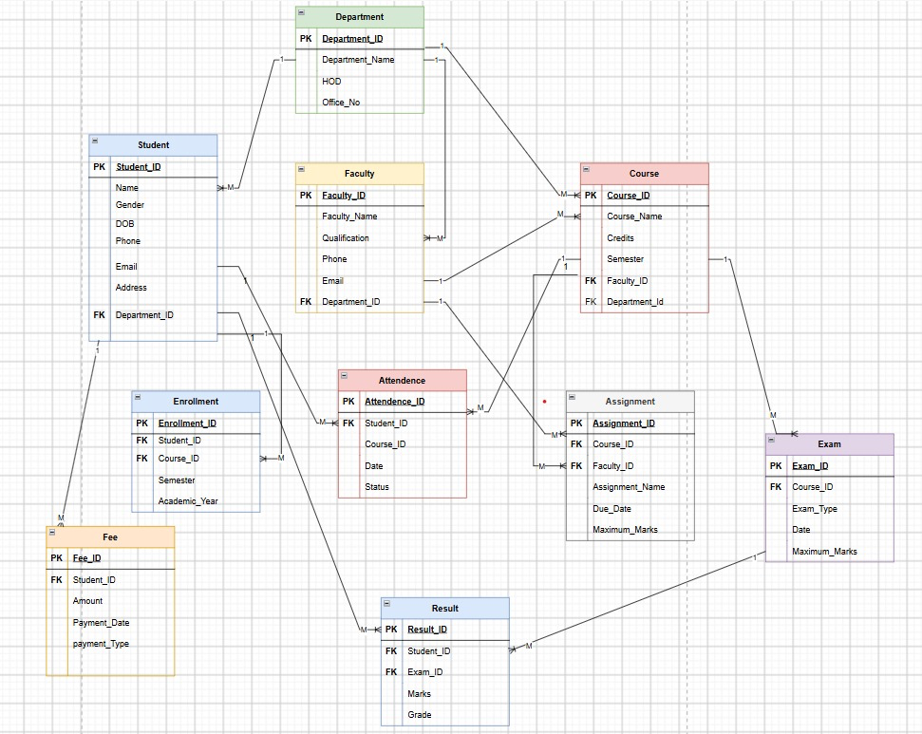
Figure 1: ER Diagram of the University Academic Management Database
The ER diagram summarizes the seven entities — Department, Student, Faculty, Course, Enrollment, Exam, and Result — along with their attributes, primary keys, foreign keys, and cardinalities, as designed in Review – I and carried into implementation in Review – II.

5. RELATIONAL SCHEMA
Table 3. Relational Schema Summary
Relation | Relational Schema
DEPARTMENT | Department_ID (PK), Department_Name, HOD, Office_No
STUDENT | Student_ID (PK), Name, Gender, DOB, Phone, Email, Address, Department_ID (FK)
FACULTY | Faculty_ID (PK), Faculty_Name, Qualification, Phone, Email, Department_ID (FK)
COURSE | Course_ID (PK), Course_Name, Credits, Semester, Faculty_ID (FK), Department_ID (FK)
ENROLLMENT | Enrollment_ID (PK), Student_ID (FK), Course_ID (FK), Semester, Academic_Year
EXAM | Exam_ID (PK), Course_ID (FK), Exam_Type, Exam_Date, Maximum_Marks
RESULT | Result_ID (PK), Student_ID (FK), Exam_ID (FK), Marks, Grade

Student and Faculty reference Department. Course references Faculty and Department. Enrollment references Student and Course. Exam references Course. Result references Student and Exam. This chain of references keeps each attribute stored in exactly one relation, consistent with the normalization discussed in Section 7.

6. TABLE DESIGN

6.1 Department Table
Table 4. Department Table Structure
Attribute | Data Type | Constraint | Description
Department_ID | INT | PRIMARY KEY | Unique department identifier
Department_Name | VARCHAR(50) | NOT NULL | Name of the department
HOD | VARCHAR(50) | — | Head of Department name
Office_No | VARCHAR(10) | UNIQUE | Department office number

6.2 Student Table
Table 5. Student Table Structure
Attribute | Data Type | Constraint | Description
Student_ID | INT | PRIMARY KEY | Unique student identifier
Name | VARCHAR(50) | NOT NULL | Student name
Gender | CHAR(1) | CHECK (M, F, O) | Gender of the student
DOB | DATE | — | Date of birth
Phone | VARCHAR(15) | — | Contact number
Email | VARCHAR(50) | UNIQUE | Student email address
Address | VARCHAR(100) | — | Residential address
Department_ID | INT | FOREIGN KEY | References Department(Department_ID)

6.3 Faculty Table
Table 6. Faculty Table Structure
Attribute | Data Type | Constraint | Description
Faculty_ID | INT | PRIMARY KEY | Unique faculty identifier
Faculty_Name | VARCHAR(50) | NOT NULL | Faculty member name
Qualification | VARCHAR(50) | — | Highest academic qualification
Phone | VARCHAR(15) | — | Contact number
Email | VARCHAR(50) | UNIQUE | Faculty email address
Department_ID | INT | FOREIGN KEY | References Department(Department_ID)

6.4 Course Table
Table 7. Course Table Structure
Attribute | Data Type | Constraint | Description
Course_ID | INT | PRIMARY KEY | Unique course identifier
Course_Name | VARCHAR(50) | NOT NULL | Name of the course
Credits | INT | CHECK (> 0) | Credit value of the course
Semester | INT | — | Semester in which the course is offered
Faculty_ID | INT | FOREIGN KEY | References Faculty(Faculty_ID)
Department_ID | INT | FOREIGN KEY | References Department(Department_ID)

6.5 Enrollment Table
Table 8. Enrollment Table Structure
Attribute | Data Type | Constraint | Description
Enrollment_ID | INT | PRIMARY KEY | Unique enrollment identifier
Student_ID | INT | NOT NULL, FOREIGN KEY | References Student(Student_ID)
Course_ID | INT | NOT NULL, FOREIGN KEY | References Course(Course_ID)
Semester | INT | — | Semester of enrollment
Academic_Year | VARCHAR(9) | — | Academic year, e.g. 2026-27
(Student_ID, Course_ID, Academic_Year) | — | UNIQUE | Prevents duplicate enrollment in the same course/year

6.6 Exam Table
Table 9. Exam Table Structure
Attribute | Data Type | Constraint | Description
Exam_ID | INT | PRIMARY KEY | Unique exam identifier
Course_ID | INT | NOT NULL, FOREIGN KEY | References Course(Course_ID)
Exam_Type | VARCHAR(20) | NOT NULL | e.g. Mid-Term, End-Term
Exam_Date | DATE | — | Date the exam is conducted
Maximum_Marks | INT | CHECK (> 0) | Maximum marks for the exam

6.7 Result Table
Table 10. Result Table Structure
Attribute | Data Type | Constraint | Description
Result_ID | INT | PRIMARY KEY | Unique result identifier
Student_ID | INT | NOT NULL, FOREIGN KEY | References Student(Student_ID)
Exam_ID | INT | NOT NULL, FOREIGN KEY | References Exam(Exam_ID)
Marks | DECIMAL(5,2) | CHECK (>= 0) | Marks obtained by the student
Grade | CHAR(2) | — | Grade obtained, e.g. A, B, C
(Student_ID, Exam_ID) | — | UNIQUE | Prevents duplicate results for the same exam

6.8 Keys and Constraints Summary
Table 11. Keys and Constraints Summary
Constraint Type | Applied To
Primary Key | Department_ID, Student_ID, Faculty_ID, Course_ID, Enrollment_ID, Exam_ID, Result_ID
Foreign Key | Student.Department_ID; Faculty.Department_ID; Course.Faculty_ID, Course.Department_ID; Enrollment.Student_ID, Enrollment.Course_ID; Exam.Course_ID; Result.Student_ID, Result.Exam_ID
NOT NULL | Department_Name, Name (Student), Faculty_Name, Course_Name, Exam_Type, and other required attributes
UNIQUE | Office_No, Email (Student & Faculty), and the composite keys on Enrollment and Result
CHECK | Student.Gender (M/F/O), Course.Credits (> 0), Exam.Maximum_Marks (> 0), Result.Marks (>= 0)

7. NORMALIZATION
Normalization organizes data into related relations to reduce redundancy and update anomalies. The database is normalized up to Third Normal Form (3NF).

7.1 Unnormalized Form (UNF)
A single academic record could repeat course, department, faculty, and result information together — for example, a student's enrollment record carrying the department name, faculty name, and exam marks all in one row, repeated for every course the student takes.

7.2 First Normal Form (1NF)
In 1NF, repeating groups are removed and every attribute holds a single atomic value. Each course enrollment is represented as its own row in the Enrollment table rather than as a repeating group inside a student's record.

7.3 Second Normal Form (2NF)
In 2NF, partial dependencies on a composite key are removed. Student-specific attributes depend only on Student_ID, course-specific attributes depend only on Course_ID, and enrollment-specific attributes (Semester, Academic_Year) depend on the full Enrollment_ID key — motivating separate Student, Course, and Enrollment relations.

7.4 Third Normal Form (3NF)
In 3NF, transitive dependencies are removed. Department details are stored once in Department rather than repeated in Student, Faculty, and Course. Faculty details are stored once in Faculty rather than repeated in Course. Exam details are stored once in Exam rather than repeated in Result. The final relations — Department, Student, Faculty, Course, Enrollment, Exam, and Result — each hold only the attributes that depend directly on their own primary key.
Relation | Reason for Separation
Department | Stores department-specific attributes once.
Student | Stores student-specific attributes and a Department_ID reference.
Faculty | Stores faculty-specific attributes and a Department_ID reference.
Course | Stores course-specific attributes and references its department and faculty.
Enrollment | Stores the student–course registration relationship.
Exam | Stores exam-specific attributes and references its course.
Result | Stores marks and grade information linked to a student and an exam.

8. SQL IMPLEMENTATION
All SQL in this project was implemented and executed in MySQL Workbench against a MySQL 8.0 server.

8.1 DDL – Data Definition Language
The database and all seven tables are created with primary keys, foreign keys, and NOT NULL / UNIQUE / CHECK constraints, for example:
CREATE DATABASE IF NOT EXISTS university_academic_management;
USE university_academic_management;

CREATE TABLE Department (
Department_ID INT PRIMARY KEY,
Department_Name VARCHAR(50) NOT NULL,
HOD VARCHAR(50),
Office_No VARCHAR(10) UNIQUE
);

CREATE TABLE Student (
Student_ID INT PRIMARY KEY,
Name VARCHAR(50) NOT NULL,
Gender CHAR(1) CHECK (Gender IN ('M', 'F', 'O')),
DOB DATE,
Phone VARCHAR(15),
Email VARCHAR(50) UNIQUE,
Address VARCHAR(100),
Department_ID INT,
FOREIGN KEY (Department_ID) REFERENCES Department(Department_ID)
ON UPDATE CASCADE ON DELETE SET NULL
);

Faculty, Course, Enrollment, Exam, and Result are created the same way, each with its own PRIMARY KEY and FOREIGN KEY references, and with CHECK constraints on Course.Credits, Exam.Maximum_Marks, and Result.Marks. The complete DDL script is provided in Appendix A (file 01_create_database_and_tables.sql).

8.2 DML – Data Manipulation Language
Sample data was inserted into all seven tables, with parent tables (Department, Faculty) populated before dependent child tables (Student, Course, Enrollment, Exam, Result):
INSERT INTO Department (Department_ID, Department_Name, HOD, Office_No) VALUES
(1, 'Computer Science', 'Dr. K. Rao', 'B-101'),
(2, 'Artificial Intelligence & ML', 'Dr. P. Kishorekumar', 'B-205');

INSERT INTO Student (Student_ID, Name, Gender, DOB, Phone, Email, Address, Department_ID) VALUES
(101, 'K. Hemanth Sai Venkata Vidya Sagar', 'M', '2005-04-12', '9876543210',
'hemanth@aditya.edu', 'Visakhapatnam', 2);

-- Update an existing record
UPDATE Student SET Phone = '9998887777' WHERE Student_ID = 101;

-- Delete a record with no dependent child rows
DELETE FROM Enrollment WHERE Enrollment_ID = 5008;

The complete sample-data set is provided in Appendix A (file 02_insert_sample_data.sql), and the UPDATE / DELETE demonstrations are in file 03_update_delete.sql.

8.3 DQL – Data Query Language
Basic retrieval queries use SELECT with WHERE, ORDER BY, DISTINCT, LIKE, and IS NOT NULL, for example:
SELECT Name, Email FROM Student
WHERE Department_ID = 2 ORDER BY Name;

SELECT DISTINCT Course_Name FROM Course;

SELECT Faculty_Name, Email FROM Faculty
WHERE Email LIKE '%@aditya.edu';

The full set of ten SELECT queries is provided in Appendix A (file 04_select_queries.sql) and in Section 9 below.

9. SQL QUERIES & SCREENSHOTS
The following 32 queries demonstrate SELECT, filtering, sorting, joins (including a LEFT JOIN and multi-table joins), aggregation, GROUP BY / HAVING, CRUD operations, and views, run against the implemented database. Screenshot placeholders below should be replaced with the actual MySQL Workbench Result Grid output before final submission.
Q1. All students
SELECT * FROM Student;
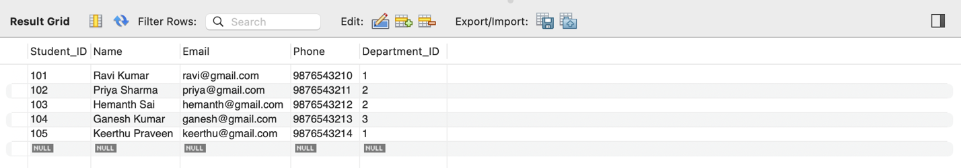Q2. All courses, most credits first
SELECT Course_Name, Credits FROM Course ORDER BY Credits DESC;
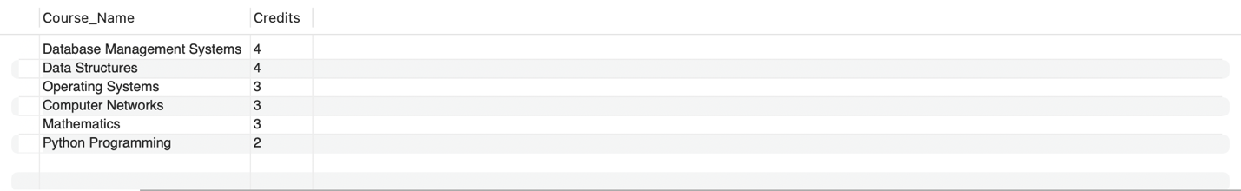Q3. Students in a specific department, sorted by name
SELECT Name, Email FROM Student WHERE Department_ID = 2 ORDER BY Name;
Q4. Unique course names offered
SELECT DISTINCT Course_Name FROM Course;
Q5. Faculty with a university email
SELECT Faculty_Name, Email FROM Faculty WHERE Email LIKE '%@aditya.edu';
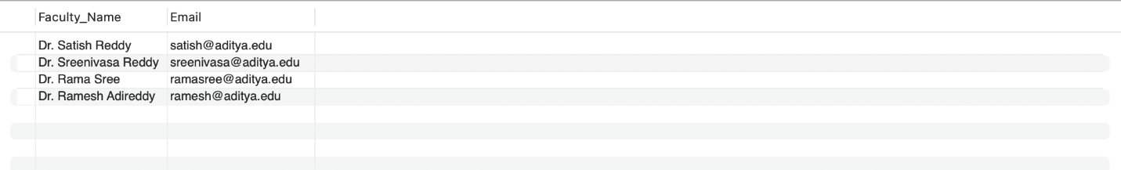

Q6. Students who have a phone number on record
SELECT Name, Phone FROM Student WHERE Phone IS NOT NULL;
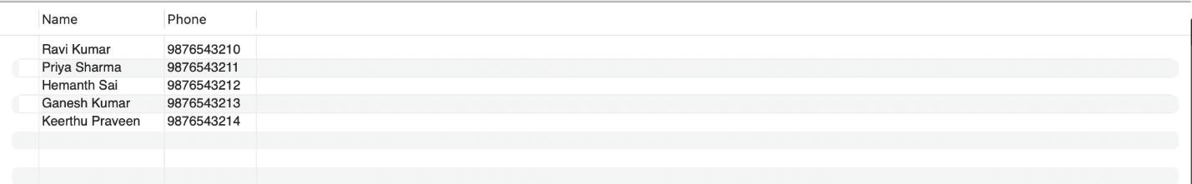

Q7. Results in a specific marks range
SELECT Result_ID, Student_ID, Marks FROM Result WHERE Marks BETWEEN 50 AND 80;
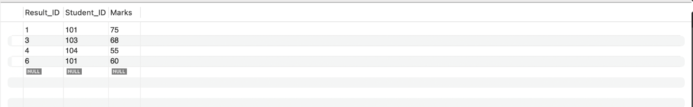

Q8. Courses in semester 4 or 5, sorted by name
SELECT Course_Name, Semester FROM Course WHERE Semester IN (4, 5) ORDER BY Course_Name;
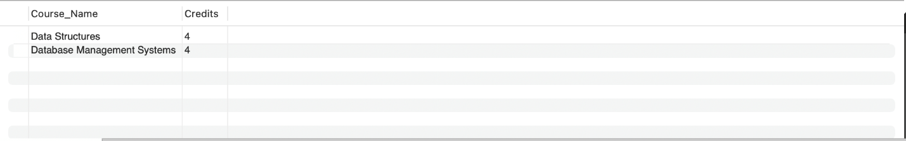

Q9. Students born on or after a given date
SELECT Name, DOB FROM Student WHERE DOB >= '2005-05-01';
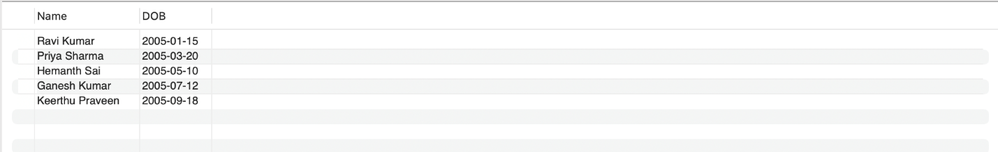

Q10. Top 3 highest results overall
SELECT Result_ID, Student_ID, Marks FROM Result ORDER BY Marks DESC LIMIT 3;
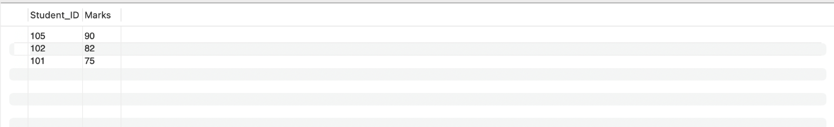

Q11. Department – Student join
SELECT S.Name, D.Department_Name FROM Student S JOIN Department D ON S.Department_ID = D.Department_ID;
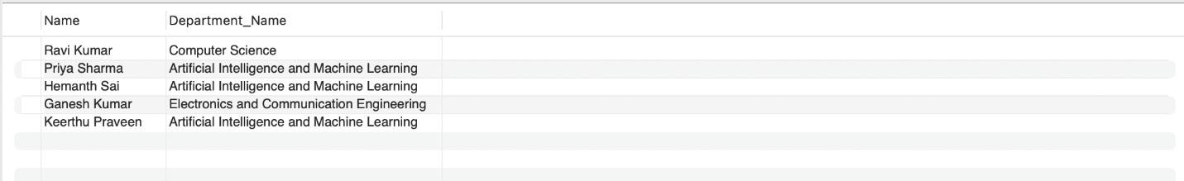

Q12. Department – Faculty join
SELECT F.Faculty_Name, D.Department_Name FROM Faculty F JOIN Department D ON F.Department_ID = D.Department_ID;
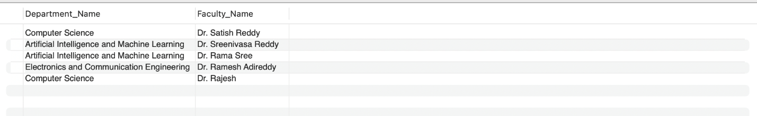

Q13. Course – Faculty join
SELECT C.Course_Name, F.Faculty_Name FROM Course C JOIN Faculty F ON C.Faculty_ID = F.Faculty_ID;

Q14. Student – Course join via Enrollment
SELECT St.Name, C.Course_Name, E.Academic_Year FROM Enrollment E JOIN Student St ON E.Student_ID = St.Student_ID JOIN Course C ON E.Course_ID = C.Course_ID;
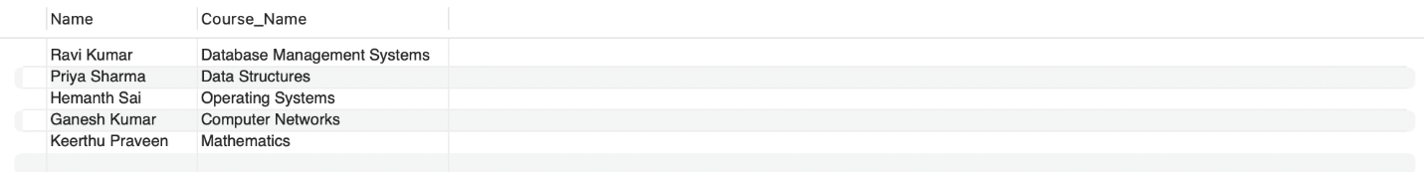

Q15. Student – Result four-table join
SELECT St.Name, C.Course_Name, Ex.Exam_Type, R.Marks, R.Grade FROM Result R JOIN Exam Ex ON R.Exam_ID = Ex.Exam_ID JOIN Course C ON Ex.Course_ID = C.Course_ID JOIN Student St ON R.Student_ID = St.Student_ID;
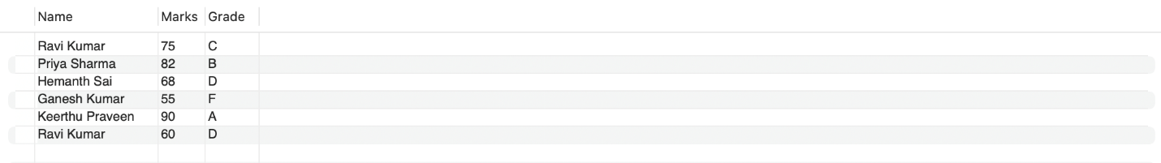

Q16. LEFT JOIN: student count per department, including zero-student departments
SELECT D.Department_Name, COUNT(S.Student_ID) AS Student_Count FROM Department D LEFT JOIN Student S ON D.Department_ID = S.Department_ID GROUP BY D.Department_Name;

Q17. Five-table join: full academic trail for every result
SELECT St.Name, D.Department_Name, C.Course_Name, Ex.Exam_Type, R.Marks FROM Result R JOIN Student St ON R.Student_ID = St.Student_ID JOIN Department D ON St.Department_ID = D.Department_ID JOIN Exam Ex ON R.Exam_ID = Ex.Exam_ID JOIN Course C ON Ex.Course_ID = C.Course_ID;
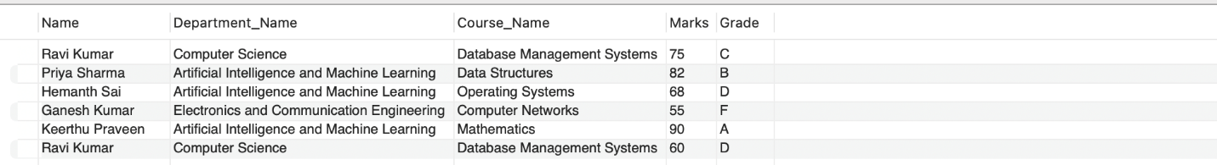

Q18. COUNT: students per department
SELECT Department_ID, COUNT(*) AS Total_Students FROM Student GROUP BY Department_ID;

Q19. COUNT: enrollments per course
SELECT Course_ID, COUNT(*) AS Total_Enrollments FROM Enrollment GROUP BY Course_ID;
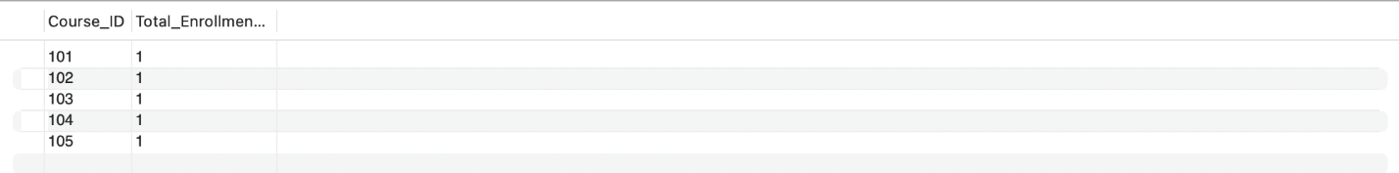

Q20. AVG + HAVING: courses averaging above 60 marks
SELECT C.Course_Name, AVG(R.Marks) AS Average_Marks FROM Result R JOIN Exam Ex ON R.Exam_ID = Ex.Exam_ID JOIN Course C ON Ex.Course_ID = C.Course_ID GROUP BY C.Course_Name HAVING AVG(R.Marks) > 60;
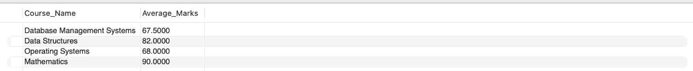

Q21. MAX / MIN marks per exam
SELECT Exam_ID, MAX(Marks) AS Highest, MIN(Marks) AS Lowest FROM Result GROUP BY Exam_ID;

Q22. SUM: total credits offered by each department
SELECT Department_ID, SUM(Credits) AS Total_Credits FROM Course GROUP BY Department_ID;

Q23. COUNT + HAVING: students enrolled in more than one course
SELECT Student_ID, COUNT(*) AS Courses_Taken FROM Enrollment GROUP BY Student_ID HAVING COUNT(*) > 1;

Q24. AVG: overall average marks across the university
SELECT AVG(Marks) AS University_Average FROM Result;

Q25. COUNT + HAVING: departments with more than one faculty member
SELECT Department_ID, COUNT(*) AS Faculty_Count FROM Faculty GROUP BY Department_ID HAVING COUNT(*) > 1;

Q26. CREATE: add a new student (CRUD)
INSERT INTO Student (Student_ID, Name, Gender, DOB, Phone, Email, Address, Department_ID) VALUES (108, 'R. Aditya', 'M', '2005-05-18', '9876543217', 'aditya@aditya.edu', 'Nellore', 1);

Q27. READ: retrieve the new student (CRUD)
SELECT * FROM Student WHERE Student_ID = 108;

Q28. UPDATE: modify the new student's address (CRUD)
UPDATE Student SET Address = 'Tirupati' WHERE Student_ID = 108;

Q29. DELETE: remove the new student (CRUD)
DELETE FROM Student WHERE Student_ID = 108;

Q30. View: consolidated student result sheet
CREATE OR REPLACE VIEW Student_Result_View AS SELECT S.Name, C.Course_Name, R.Marks, R.Grade FROM Result R JOIN Exam Ex ON R.Exam_ID = Ex.Exam_ID JOIN Course C ON Ex.Course_ID = C.Course_ID JOIN Student S ON R.Student_ID = S.Student_ID;
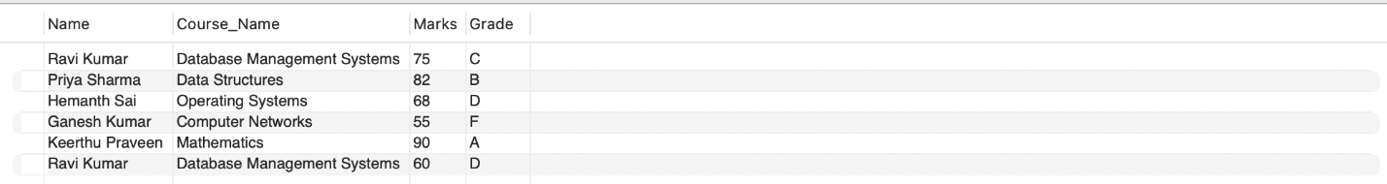

Q31. View: students who scored an A grade
SELECT * FROM Student_Result_View WHERE Grade = 'A';

Q32. View: consolidated enrollment sheet
CREATE OR REPLACE VIEW Student_Enrollment_View AS SELECT S.Name, C.Course_Name, E.Semester, E.Academic_Year FROM Enrollment E JOIN Student S ON E.Student_ID = S.Student_ID JOIN Course C ON E.Course_ID = C.Course_ID;
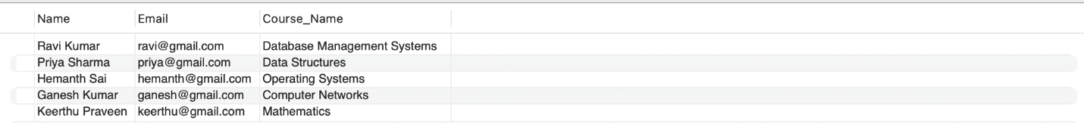

9.1 Data Integrity and Validation
The following statements were used to demonstrate that the database's constraints reject invalid data. Each is expected to fail with the error shown; these were tested one at a time in MySQL Workbench.
Validation | Statement | Expected Result
Entity integrity (duplicate PK) | INSERT INTO Department (Department_ID, Department_Name) VALUES (1, 'Duplicate Dept'); | ERROR 1062: Duplicate entry '1' for key 'PRIMARY'
Referential integrity (invalid FK) | INSERT INTO Student (Student_ID, Name, Department_ID) VALUES (999, 'Ghost Student', 99); | ERROR 1452: foreign key constraint fails
Uniqueness (duplicate email) | INSERT INTO Student (Student_ID, Name, Email) VALUES (110, 'Copy Cat', 'hemanth@aditya.edu'); | ERROR 1062: Duplicate entry for key 'Email'
Domain validation (negative credits) | INSERT INTO Course (Course_ID, Course_Name, Credits) VALUES (399, 'Bad Course', -2); | ERROR 3819: Check constraint is violated
Mandatory field (NULL in NOT NULL column) | INSERT INTO Faculty (Faculty_ID, Faculty_Name) VALUES (299, NULL); | ERROR 1048: Column 'Faculty_Name' cannot be null

10. CONCLUSION
The University Academic Management Database System provides a structured relational database solution for managing core academic information. The design organizes departments, students, faculty, courses, enrollments, exams, and results into seven related tables and applies primary keys, foreign keys, uniqueness rules, NOT NULL conditions, and CHECK constraints to support data integrity. Normalization up to 3NF reduces redundancy and update anomalies. The SQL implementation — DDL, DML, DQL, joins, aggregate functions, CRUD operations, and views — demonstrates that the database supports insertion, modification, retrieval, aggregation, and academic reporting. The project, carried out across Review – I (design) and Review – II (implementation), provides a working foundation that can be extended into a complete academic information system.

11.FUTURE ENHANCEMENT
- Role-based access for administrators, faculty, and other authorized users.
- Attendance and leave management.
- Fee and scholarship management.
- Timetable and classroom allocation.
- Automated reports and analytics dashboards.
- Backup, recovery, audit logging, and stronger database security.
- A web or mobile application interface over the existing database.

12.REFERENCES
- Silberschatz, A., Korth, H. F., and Sudarshan, S., Database System Concepts, McGraw Hill.

- Elmasri, R. and Navathe, S. B., Fundamentals of Database Systems, Pearson.
- MySQL 8.0 Reference Manual, Oracle Corporation.
- Course lecture notes, laboratory exercises, and approved DBMS learning resources.

